Dress Standards
School Dress and Grooming Standards should be followed whenever attending any school activity. A student’s manner of dress and grooming should not cause a distraction or interruption to learning. Students are expected to come modestly dressed in a manner that reflects pride in themselves and the school. The principal will make final decisions. Students who come dressed inappropriately may be given the choice between wearing appropriate clothing issued by the school (if available) or calling home to arrange for appropriate attire. Please make dress and grooming choices that promote our school’s mission: Learning First!
- Students must wear shoes. Footwear should be appropriate for active play at recess and P.E. Shoes that provide ankle support and protect toes are recommended. Flipflop and wheeled shoes are not appropriate.
- All shirts and tops must have at least 3 fingers width of material covering the shoulders. If crop-top or midriff type shirts are worn, an undershirt should be worn to cover the mid-section.
- Shorts should not be shorter than mid-thigh and styles (such as rips or frayed) must not expose areas already covered by policy.
- All clothing that exposes the mid-section, buttocks, or undergarments is not allowed.
- Clothing attachments which could be considered weapons (spikes, chains, wristbands, etc.) will not be allowed.
- Any attire, hair style or color, piercing, or makeup which significantly disrupts the educational process or is a safety concern should not be worn.
- Hats are allowed outside.
District Dress Code Link: https://resources.finalsite.net/images/v1635867905/davisk12utus/lib2nzljfgorkvmbjnxm/5S-100StudentConductandDiscipline.pdf See policy sections 2.1.1 & 12.5
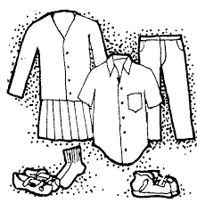
Revised and approved by the Taylor Elementary Community Council on 4 October 2022

